**Project Design Phase 1**

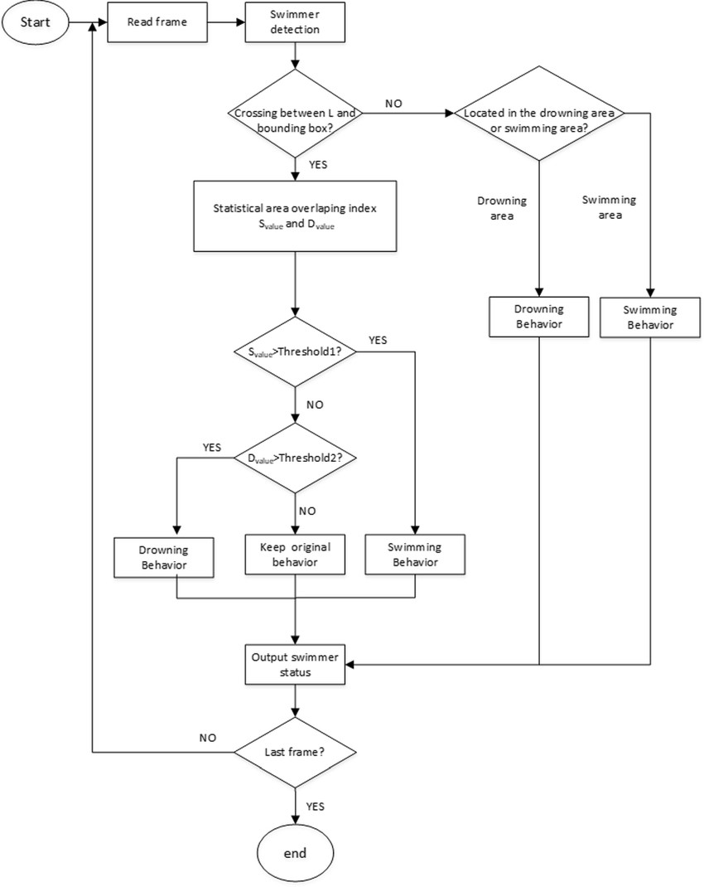**Solution Architecture**

|  |  |
| --- | --- |
| Date | 18 October 2022 |
| Team id | PNT2022TMID1430922 |
| Project name | Project - Virtual eye - LifeGuard For  Swimming Pools To Detect Active  Drowning |
| Maximum Marks | 4 Marks |

**Solution Architecture Diagram**

: